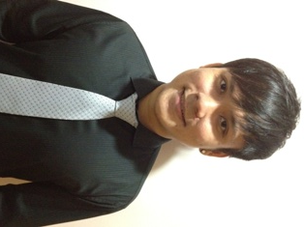

It was a decision met by resistance from many of my friends when I decided
to take on the challenge to complete ACCA since most believe that the
journey will be arduous and tedious. This did not stop me from pursuing my
passion but instead, it gave me the drive to take on the challenge. I was
not able to relate any of my working experience to my studies because
of the irrelevancy to the nature of my job. Therefore, when i decided to
leave the Republic of Singapore Air Force to further pursue my passion, I
was met with multiple setbacks.

Due to my lack of accounting experience, most of the companies did not
respond to my application, or even if they did, they had doubts on my
ability to take on the applied role due to my job experience. Luckily for
me, i was able to land a suitable job after many months of searching and
hunting. Therefore, I have reminded myself of this difficulty and I do not
wish that others will go through this pain or at least, a reduced pain by
creating opportunity and motivating them along the way.

Thus, by being a part of AISS as a committee member, I will be able to
reach out to a larger group of accounting-aspired students, whom lack of
experience and are seeking for suitable job, through various mediums like
(1) organising corporate visits, (2) career fair, (3) career talk or even
(4) interacting with experienced accounting professionals. I hope to
influence others on the need to stay positive and motivated during tough
times and never stop pursuing their dream or passion because "tough times
don't last, tough men do".

