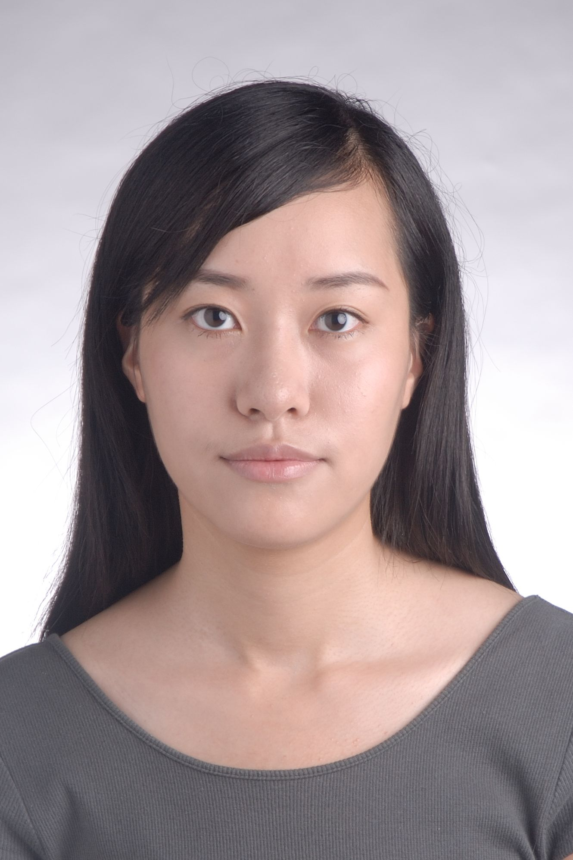

I am glad that I can join in AISS as a committee member. As a committee
member, I will try my best to do my own work, and cooperate with other
members, try to help them in the details if iI can. Hope I can be a careful
and creative one in the group, can drive and motive the students and
myself. I am looking forward from the brand new term.

